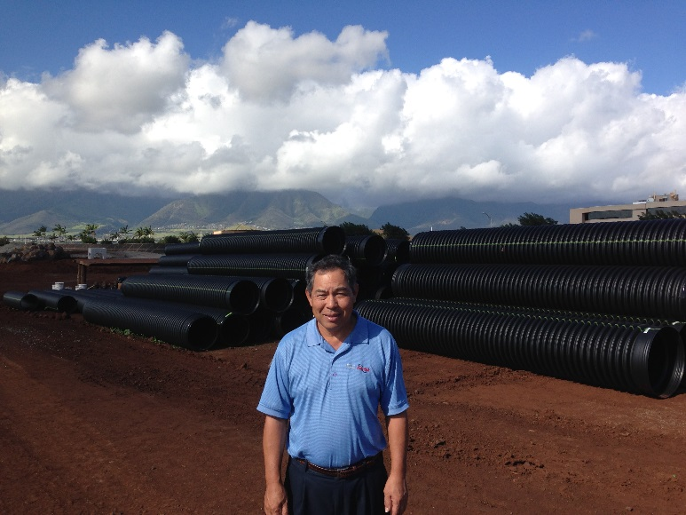

Hawaii Water and Drainage, LLC is a premier Hawaii manufacturers’ representative of quality domestic civil construction products for water distribution, storm water drainage and waste water conveyance.

Our goal is to solve Hawaii civil construction problems with the best and latest products and technologies at a reasonable and competitive price.

We select only quality domestic civil engineering products that meet or exceed industry standards and have been successful installed in numerous projects for a prolong time period.